(Approx. 661 words)

Tom’s Tech-Notes
Windows 10 Spotlight Pictures How to Find and Save Them
By Tom Burt, Editor, Sun City Summerlin Computer Club, NV
June 2018 issue, The Gigabytes Gazette
www.scscc.club/
tomburt89134 (at) cox.net

Overview
One of the neat features in Windows 10 is the ability to set up the lock / login screen’s background wallpaper to a rotating set of interesting, beautiful, curated 1920x1080 dpi images provided by Microsoft. The official name for these is Windows Spotlight. Every day or two the background image changes and new ones appear regularly as older ones vanish, not to be seen again – at least for a long time. Here’s a recent example:


Turning on Windows Spotlight
To see the Windows Spotlight images at login, you first need to turn on Windows Spotlight in the Settings > Personalization > Lock screen panel. Once there, click the dropdown arrow of the Background list box and choose Windows Spotlight. Then exit out of the Settings manager. (See the screen shot below.) If Windows Spotlight was not previously turned on, it will take some time for Windows 10 to download some background images to display.
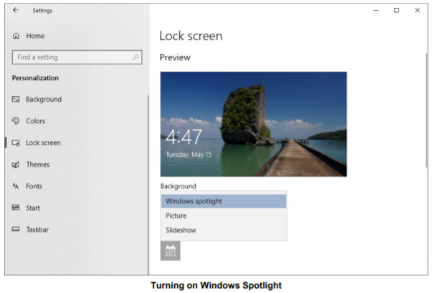
Finding the Windows Spotlight Images, The Windows Spotlight images are tucked away deep in a hidden folder. To find them, you need to launch the Windows File Explorer by clicking the folder icon in the task bar or double-clicking This PC. Click the View tab in the ribbon and then make sure that the Hidden Items checkbox is checked. This will cause File Explorer to show hidden files and folders.
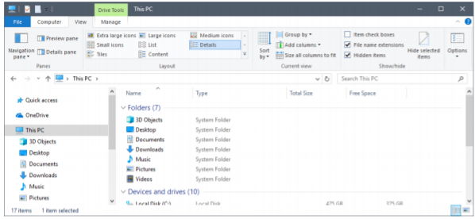

Now some patience is required. Progressively click through the following cascade of file folders:
C:\Users\\AppData\Local\Packages\ Microsoft.Windows.ContentDeliveryManager_cw5n1h2txyewy\LocalState\Assets

Make sure you have selected the Details view on the View tab. In the Assets folder, you will see a collection of files with very long file names, each consisting of a jumble of letters and numbers. These file names have no extensions, but internally are .JPG files.

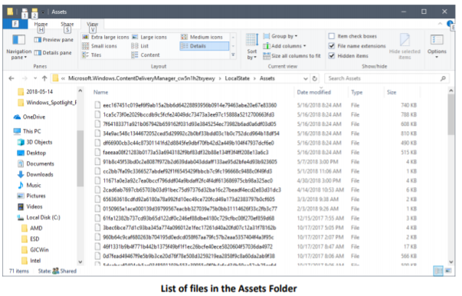

Saving a Copy of the Windows Spotlight Images for Your Own Use Now that the Spotlight images have been located, it is easy to copy them to another folder and then rename each so that Windows will recognize them as .JPG images. Using the File Explorer, Create a new folder to hold the copied images, for example: Pictures\WindowsSpotlightPics. You’ll only need to do this once.

In the Assets folder, select the files you wish to copy using click, Shift-click and Ctrl-click. Skip any very small files, as these are not Spotlight images. Next, right-click on the selected set and choose Copy from the pop-up menu. Now navigate to your new folder, right click in the view pane and choose paste from the pop-up menu. File Explorer will copy your selected set of files (See the screen shot below).

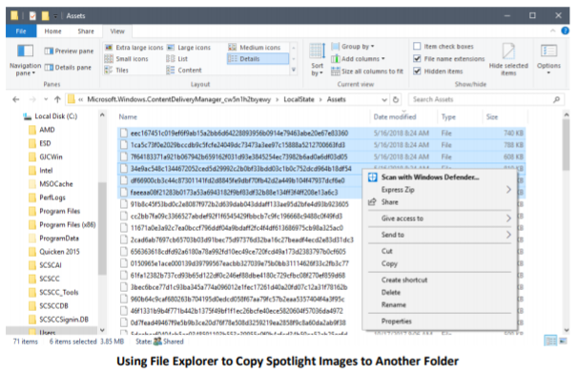

Renaming Your Saved Image Files
The last step is to rename ach of the copied files to a more eye-friendly name that includes the .JPG file extension.

Using File Explorer, navigate to your new Windows Spotlight folder. Choose the “Large Icons view in the View tab. Right-click on one of the file names, select Rename, and then type in a new name such as: Spotlight001.jpg. With a known file extension, File Explorer should immediately display that renamed image as an image thumbnail.


Repeat the above steps for each of the copied images, using a different file name for each one. You will find that some of the images are portrait format versions of the same images. These are apparently for use on cell phones and tablets. You can keep or discard these as you choose.

Summary

The Windows Spotlight images are replaced every few days. To build up a large collection, you will want to check the Assets folder every few days for new files and follow the steps outlined above. You can view the contents of your WindowsSpotlightPics as a slide show or even burn the complete set to a DVD or flash drive for display on your HDTV. Have fun!



